**HOSPITAL MANAGEMENT SYSTEM**

*Design Project Report submitted*

*in*

*partial fulfillment*

*of*

*the requirements for the award of the degree*

*of*

BACHELOR OF TECHNOLOGY

*in*

COMPUTER SCIENCE AND ENGINERING

*Submitted by*

***1. AFZAL M.A (AJC15CS004)***

***2. ALPHY ABRAHAM (AJC15CS012)***

***3. ESTHA THOMAS (AJC15CS049)***

***4. JERIN RAJU (AJC15CS055)***



DEPARTMENT OF COMPUTER SCIENCE AND ENGINEERING

AMAL JYOTHI COLLEGE OF ENGINEERING

KANJIRAPPALLY

*Affiliated to APJ Abdul Kalam Technological University*

*November 2017*

**DEPARTMENT OF COMPUTER SCIENCE AND ENGINEERING**

**AMAL JYOTHI COLLEGE OF ENGINEERING**

**KANJIRAPPALLY**



**CERTIFICATE**

*Certified that the Design Project Report* ***HOSPITAL MANAGEMENT SYSTEM*** *is the bonafide work of* ***AFZAL M.A(AJC15CS004),ALPHY ABRAHAM(AJC15CS012),ESTHA THOMAS(AJC15CS049),JERIN RAJU(AJC15CS055)*** *in partial fulfillment of the requirements for the award of the Degree of Bachelor of Technology in Computer Science and Engineering under APJ Abdul Kalam Technological University during the year 2017.*

Ms. Niya Joseph, Mr. Jayakrishna V Prof. Manoj T. Joy

**Coordinators Head of Department**

SYSTEM REQUIREMENT SPECIFICATION

Contents

Contents 4

1 Introduction 5

1.1 Purpose 5

1.2 Scope 5

1.3 Product / System Overview 5

1.4 User Characteristics 5

1.5 Definitions, Acronyms & Abbreviations 6

1.6 Constraints 6

1.7 Assumptions and Dependencies 6

1.8 References 6

2 Functional Requirements 6

3 Non-Functional Requirements 12

3.1 Performance Requirements 12

3.2 Security Requirements 12

3.3 Software System Attributes 12

4 External Interface Requirements 13

4.1 User Interfaces 13

4.2 Hardware Interfaces 13

4.3 Software Interfaces 13

4.4 Communication Interfaces 13

5 User Acceptance Criteria 13

6 Appendices 14

# Introduction

## Purpose

This project is aimed to automate the hospital management system. This project is developed mainly to administrate doctor's appointment with the patients. The purpose of the project entitled as HOSPITAL MANAGEMENT SYSTEM is to computerize the Front Office Management of Hospital to develop software which is user friendly, simple, fast, and cost – effective. It deals with the collection of patient’s information, diagnosis details, etc.

## Scope

The application can be used in any university or college that has medical/health care centre within the institution for maintaining patients test and treatment details by customizing some of the features that suit that particular institution.

It can be used in any Hospital, Clinic, Dispensary or pathology labs for maintaining the patient’s details and their test results

## Product / System Overview

The function of this system deals with registering the new Patient for IPD and giving unique Identification Number to the Patient. This number is unique throughout the system for identifying the patient. This Patient identification number is also created for each separate visit of the patient. This is also a part of registering patient. Patient ID is used for tracking of medical records of the patient for that particular IPD admission. All the medical record of the patient is identified by this patient ID.

The system designed has a feature that it contains the entire doctor’s information that is in the line of treatment of that particular disease. It contains their room number, nurses and doctors attaining that particular patient. This will help the patients to see the doctors as soon as possible as they may be first comers to the hospital.

## User Characteristics

*.*

Every user should be:

1. Comfortable of working with the computer.

2. He must have knowledge in medical field.

3. He must have basic knowledge of English too.

## Definitions, Acronyms & Abbreviations

The definition of the terms which are used in this SRS document are –

|  |  |
| --- | --- |
| Patients | The one who come in the hospital |
| G.U.I | Graphical User Interface |
| D.BM.S | Database Management System |
| SDD | System Design Description |
| SRS | System Requirement Specification |
| PHP | Hypertext Preprocessor |

## Constraints

* Database : The system shall use MYSQL Database, which is open source and free.
* Operating System :The development environment shall be Windows 2000.
* Web-Based : The system shall be a Web-Based application.

## Assumptions and Dependencies

1. It is assumed that the hospital will have enough trained staff to take care of the system.

2. It is also assumed that one hundred IBM compatible computers will be available before the system is installed and tested.

## References

1. www.google.com

2. www.scribd.com

# Functional Requirements

These are inherent functionalities that the system is purposely expected to perform to achieve the goals for the development.

These include –

1. Data Storage – the system provides data storage capabilities. This is enhanced by database management system that is capable of managing the storage requirements.

2. Retrieval Of Data – It should be easier to retrieve data from the database through procedure designed to ensure efficiency.

3. Registration Processing – Registration should be done promptly and without delay or errors.

4. Searching – System should retrieve records on the click of a button without unnecessary delays as requested by the user.

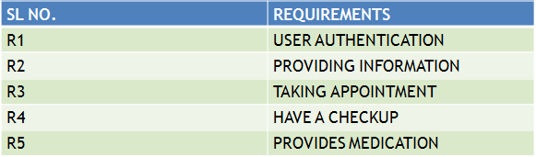

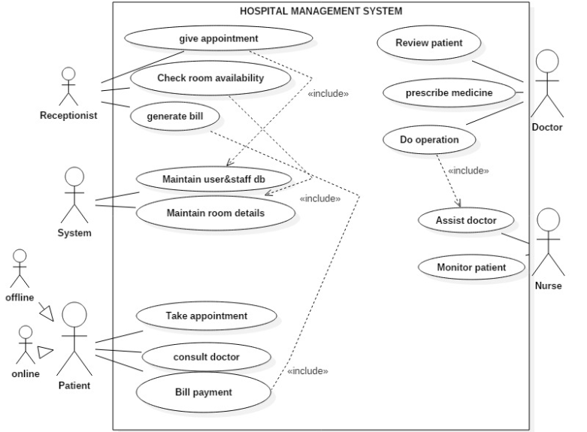

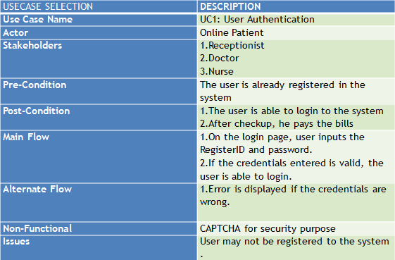

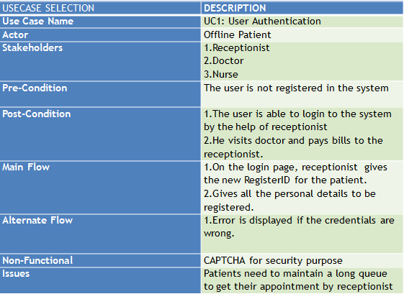

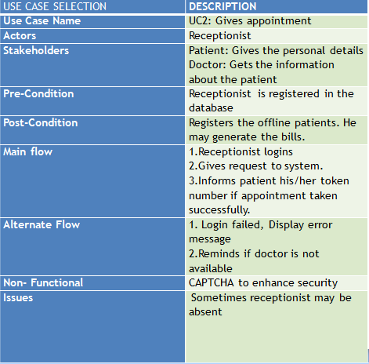

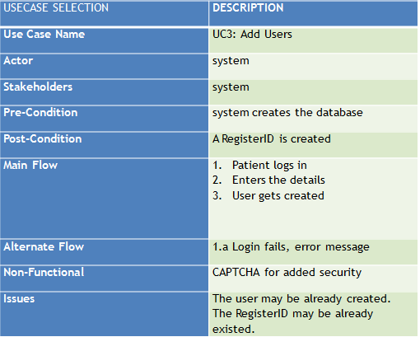

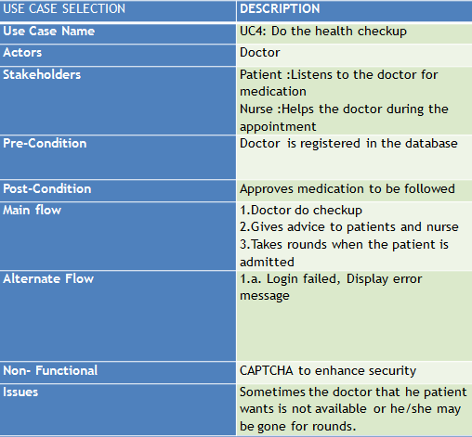

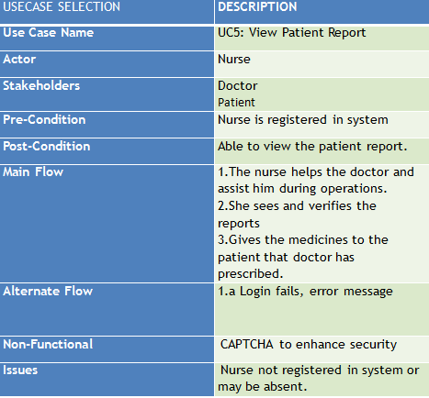

# Non-Functional Requirements

These are the functionalities that are generally implied and our factored in as characteristics of a good system. They are not part of system requirements.

1. Should be reliable and efficient.

2. Easy to maintain.

3. Ensure security of stored information.

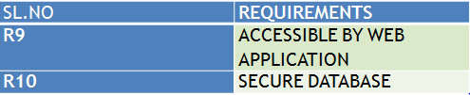

## Performance Requirements

**ResponseTime**  
  The system shall give responses in 1 second after checking the patient’s information.

**Capacity**  
 The System must support 1000 people at a time.

**User-interface**   
The user-interface screen shall respond within 5 seconds.

**Conformity**  
  The systems must conform to the Microsoft Accessibility guidelines *.*

## Security Requirements

1. Patient Identification – The system requires the patient to identify himself/herself using Patient identification number.

2. Login I.D – Any user who uses the system shall have Login I.D and password.

3. Any modification for the database shall be synchronized and only by the administrator.

4. Administrator’s Rights – Administrators shall able to view and modify all information.

## Software System Attributes

1. Reliability – The reliability of the proposed system is high. The reason for the increased reliability is that there will be a proper storage of information.

2. Availability – The system shall be available all the time.

3. Maintainability – The system is easy to maintain and easy to operate.

# 4. External Interface Requirements

## User Interfaces

*.*

The software provides a good graphical interface for the user. Any administrator can operate onto the system, performing the required tasks such as create, update and viewing the details of the patients.

Allows users to view quick reports in between the particular time.

## Hardware Interfaces

1. Operating system – Windows

2. Hard disk: 40 GB

3. RAM: 256 MB

4. Processor: Pentium® Dual – core CPU

## Software Interfaces

1. JAVA language

2. Net Beans IDE 7.0.1

3. MS SQL server 2005

# 5. Acceptance Criteria

Provides recaptcha for user.

# 6. Appendices

<http://www.ofnisystems.com>

[*http://www.opencodez.com*](http://www.opencodez.com)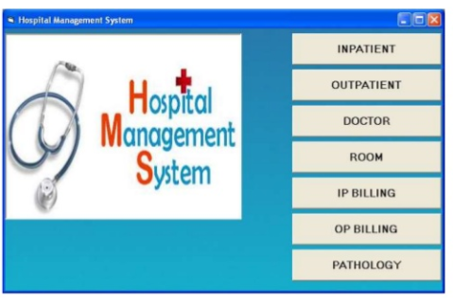

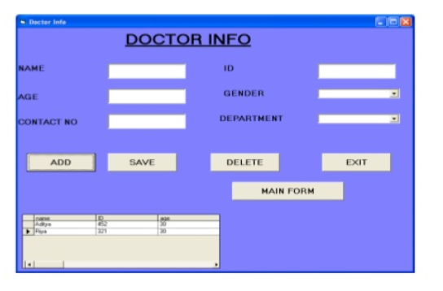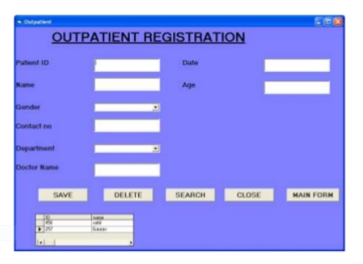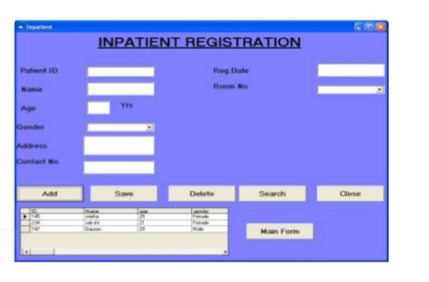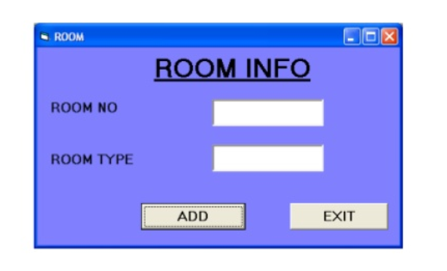

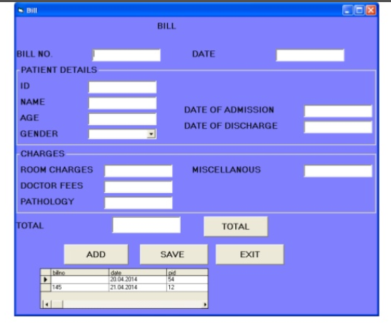

SYSTEM DESIGN SPECIFICATION

Contents

Contents 19

1 Introduction 20

1.1 Purpose 20

1.2 Scope 20

1.3 Product / System Overview 20

1.4 User Characteristics 20

1.5 Definitions, Acronyms & Abbreviations 20

1.6 Design and Implementation Constraints 21

1.7 Assumptions and Dependencies 21

1.8 References 21

2 Low Level Design (Detail Design) 21

2.1 Analysis Model 22

2.2 Design Model 22

3 Database Design 23

3.1 ER Model 24

3.2 Database Object Definitions 25

1. Appendices 26

# Introduction

## 1.1Purpose

This project is aimed to automate the hospital management system. This project is developed mainly to administrate doctor's appointment with the patients. The purpose of the project entitled as HOSPITAL MANAGEMENT SYSTEM is to computerize the Front Office Management of Hospital to develop software which is user friendly, simple, fast, and cost – effective. It deals with the collection of patient’s information, diagnosis details, etc.

## 1.2Scope

The application can be used in any university or college that has medical/health care centre within the institution for maintaining patients test and treatment details by customizing some of the features that suit that particular institution.

It can be used in any Hospital, Clinic, Dispensary or pathology labs for maintaining the patients details and their test results.

## 1.3Product / System Overview

The function of this system deals with registering the new Patient for IPD and giving unique Identification Number to the Patient. This number is unique throughout the system for identifying the patient. This Patient identification number is also created for each separate visit of the patient. This is also a part of registering patient. Patient ID is used for tracking of medical records of the patient for that particular IPD admission. All the medical record of the patient is identified by this patient ID.

The system designed has a feature that it contains the entire doctor’s information that is in the line of treatment of that particular disease. It contains their room number, nurses and doctors attaining that particular patient. This will help the patients to see the doctors as soon as possible as they may be first comers to the hospital.

## 1.4User Characteristics

Every user should be:

1. Comfortable of working with the computer.

2. He must have knowledge in medical field.

3. He must have basic knowledge of English too.

## 1.5Definitions, Acronyms & Abbreviations

The definition of the terms which are used in this SRS document are –

|  |  |
| --- | --- |
| Patients | The one who come in the hospital |
| G.U.I | Graphical User Interface |
| D.BM.S | Database Management System |
| SDD | System Design Description |
| SRS | System Requirement Specification |
| PHP | Hypertext Preprocessor |

## 1.6Design and Implementation Constraints

*1.The size of the database increases day by day,increasing the load on the database backup and data maintenance activity.*

*2.Training for simple computer operations is necessary for the user’s working on the system.*

## 1.7Assumptions and Dependencies

1. It is assumed that the hospital will have enough trained staff to take care of the system.

2. It is also assumed that one hundred IBM compatible computers will be available before the system is installed and tested.

## 1.8References

1. www.google.com

2. www.scribd.com

# 2.Low Level Design (Detail Design)

## 2.1Analysis Model

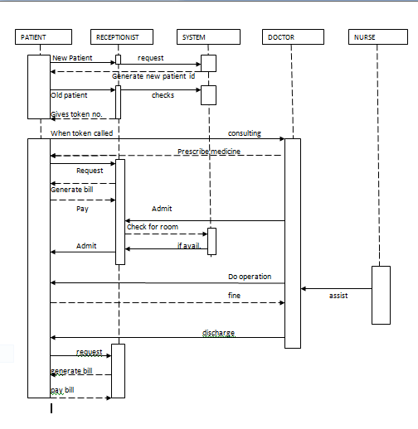

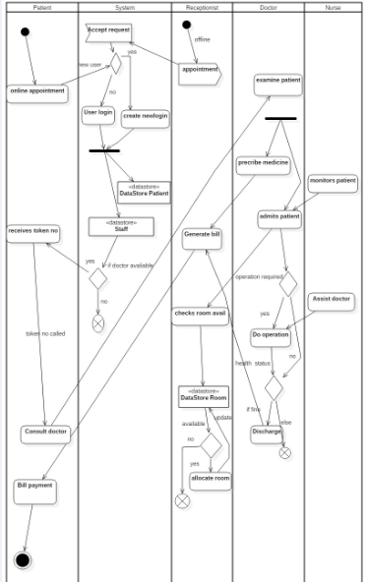

## 2.2Design Model

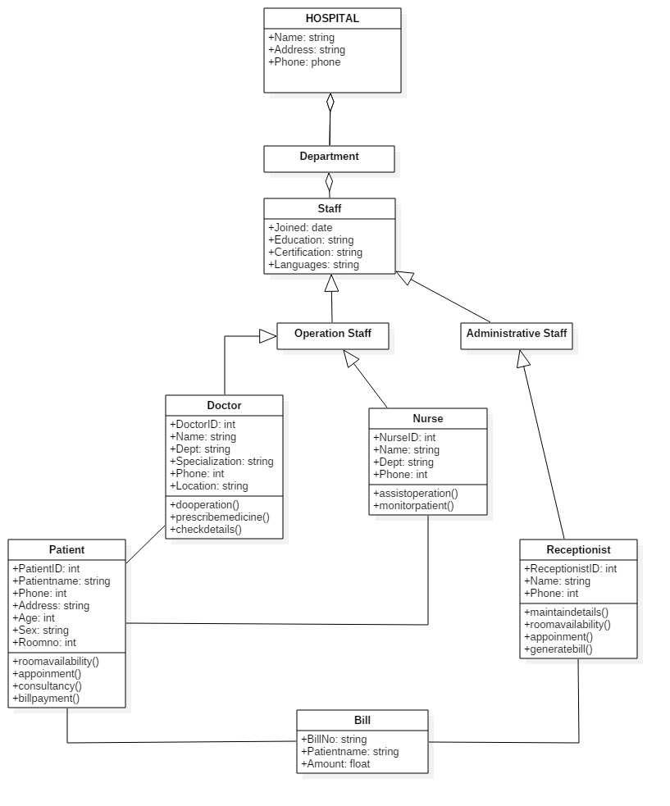

# 3Database Design

## 3.1ER Model

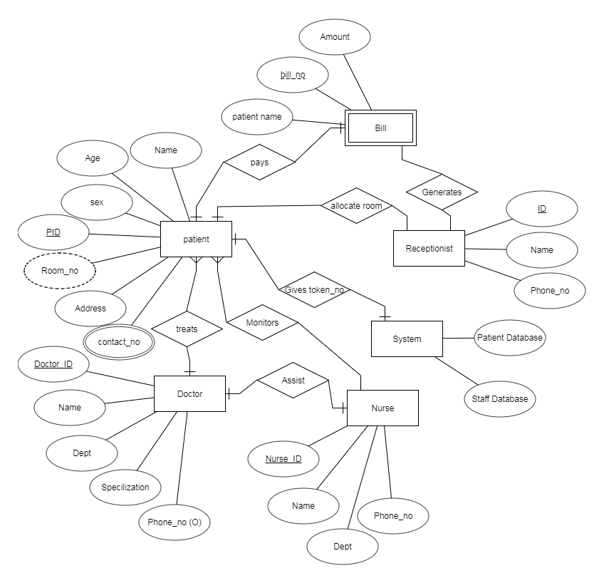

## 3.2Database Object Definitions

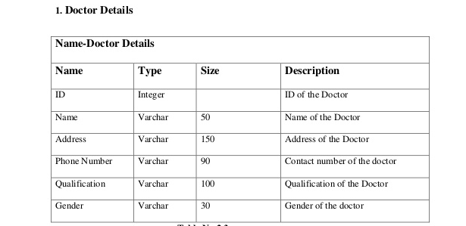

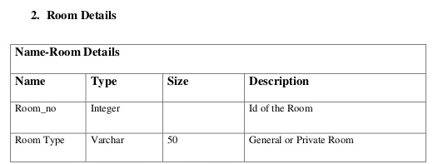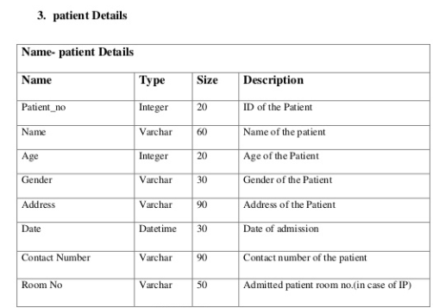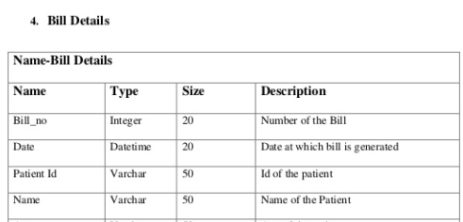

# 4.Appendices

<http://www.ofnisystems.com>

[*http://www.opencodez.com*](http://www.opencodez.com)**

**

**